







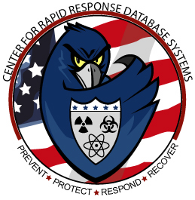



FIFTH STATEWIDE SYMPOSIUM ON HOMELAND SECURITY
Featuring
“Emergency Preparedness and Response”
Sponsored by
NJ Universities Consortium on Homeland Security
Hosted by
NJIT & NJ Homeland Security Technology Systems Center
Tuesday, November 29th, 2005
8:30 AM – 3:30 PM

Registration Form
Name:
Affiliation:
Address:
Contact Information:Phone:
Fax:
e-mail:

Buffet Style Luncheon Provided by the Center

Send Registration to: Arthur Tokle, NJHSTSC
FAX: 973-596-6056 or e.mail arthur.tokle@njit.edu
RSVP By Tuesday November 22, 2005

